TP 1 réseaux ubiquitaires

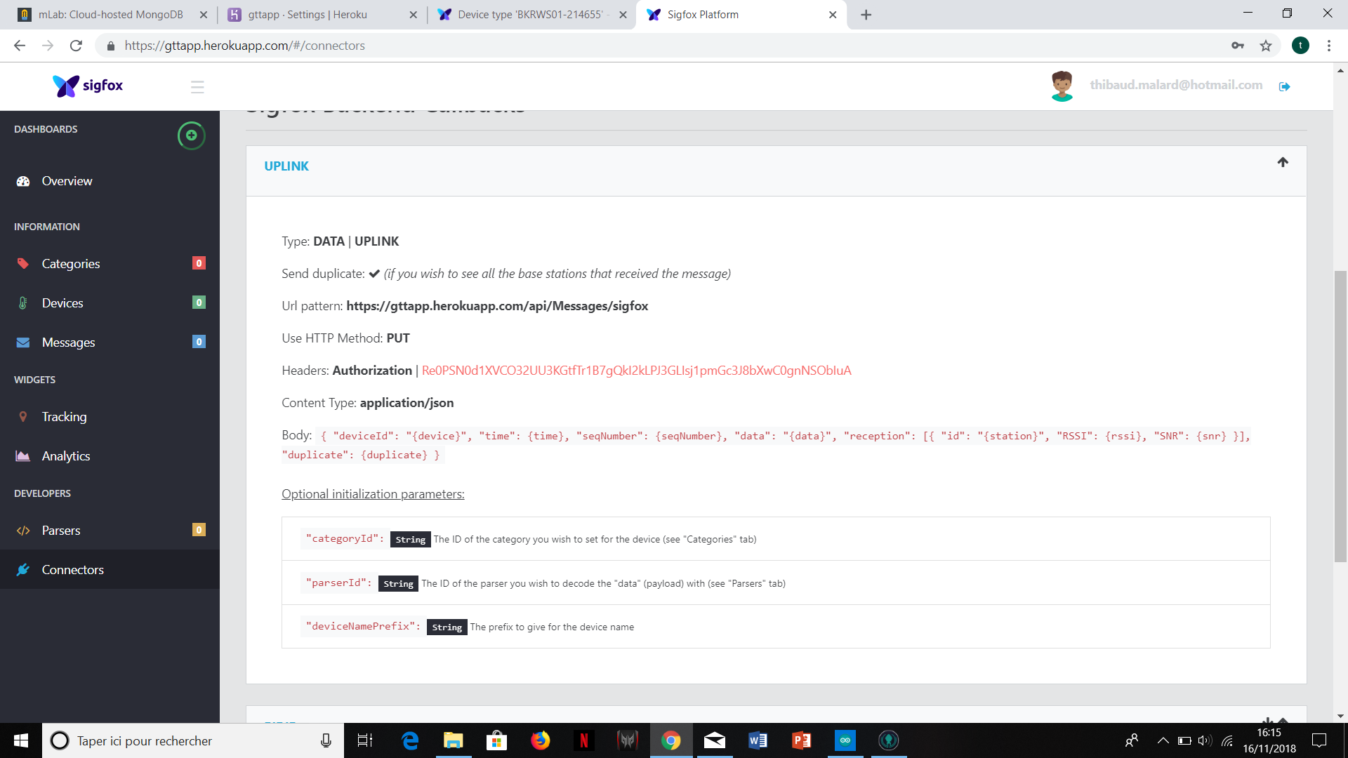

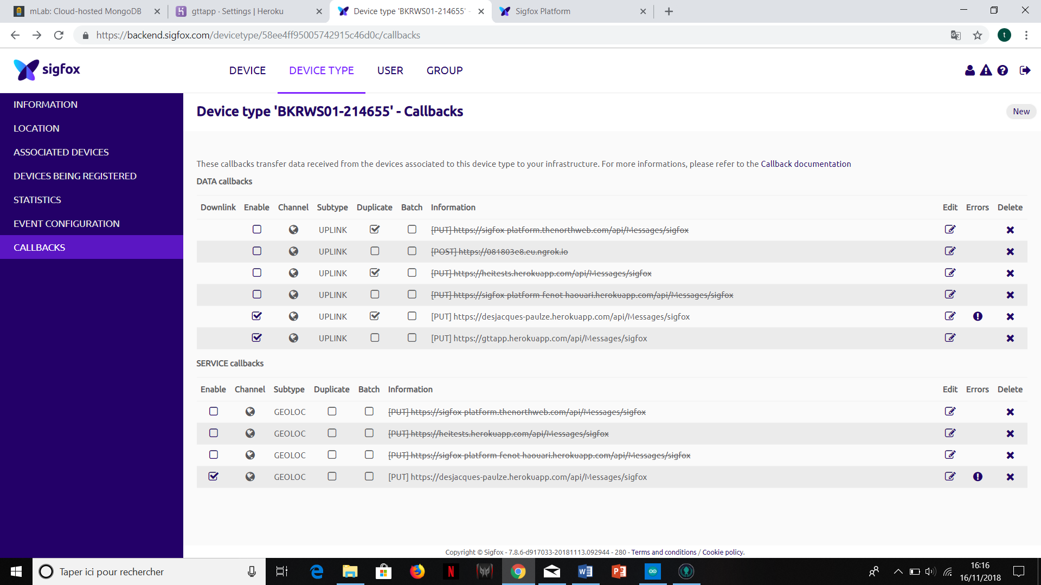

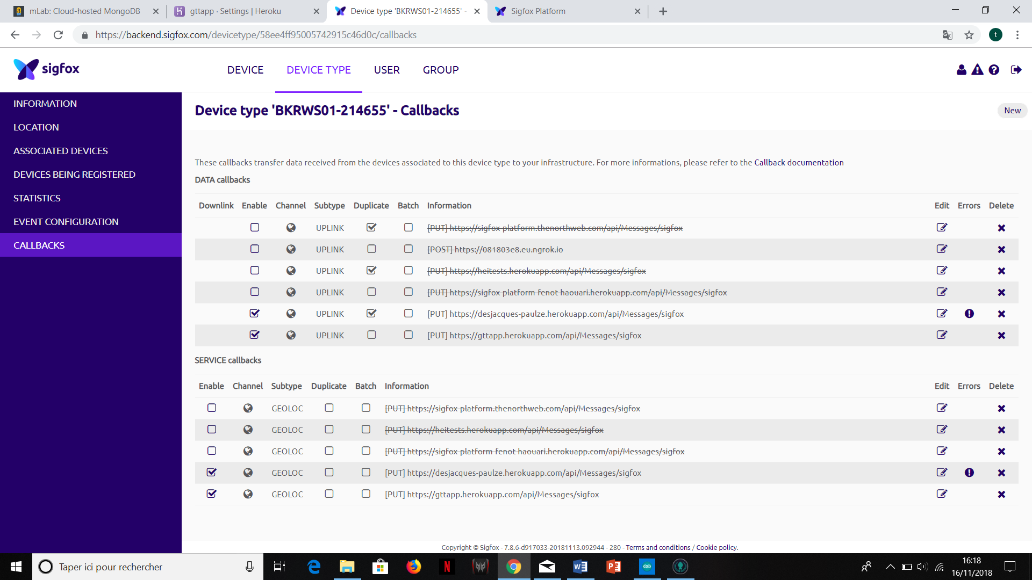

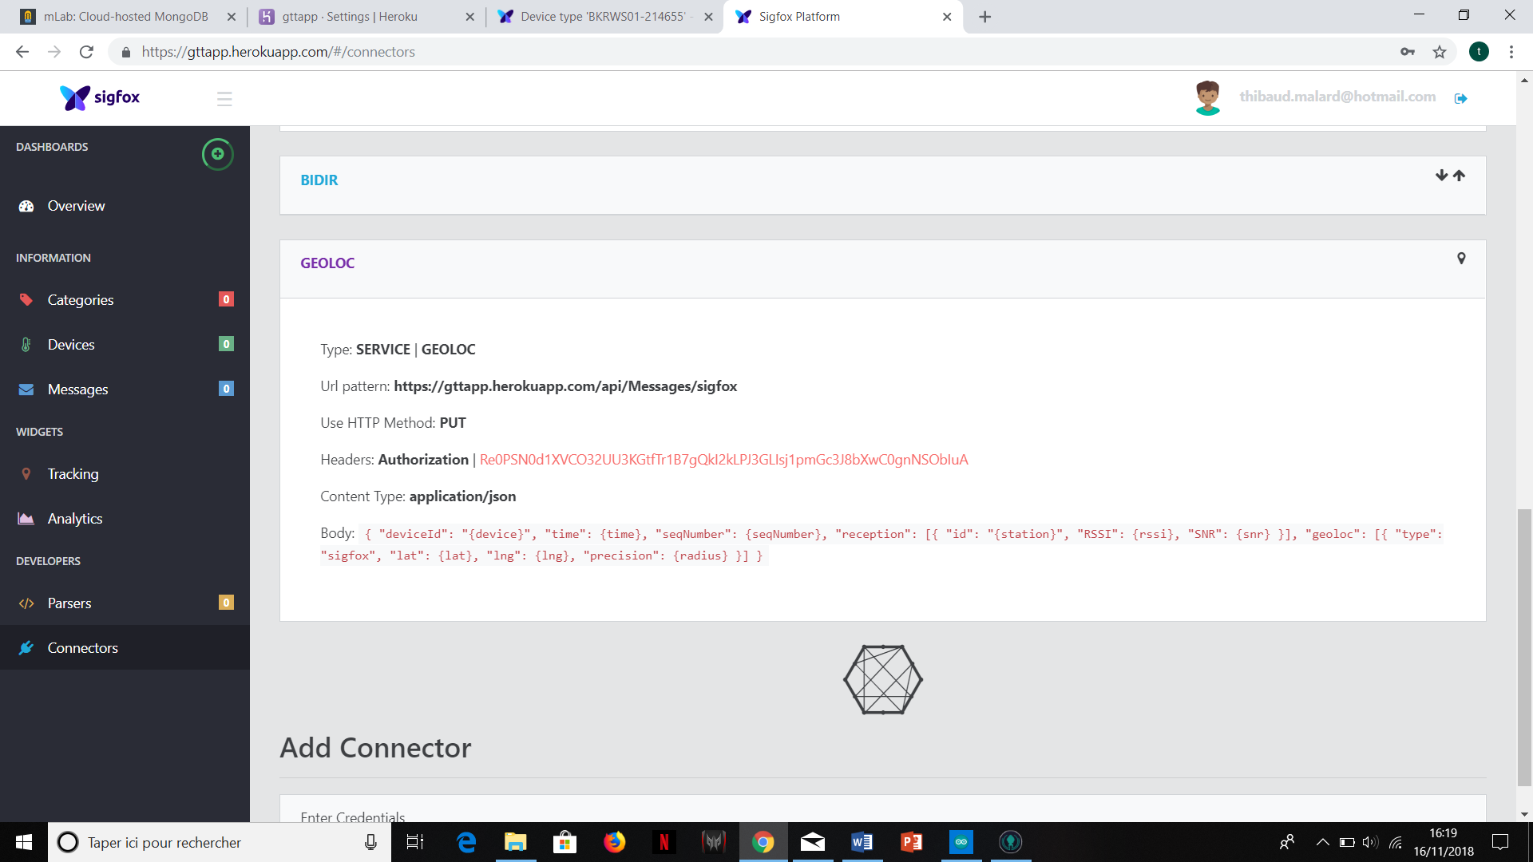

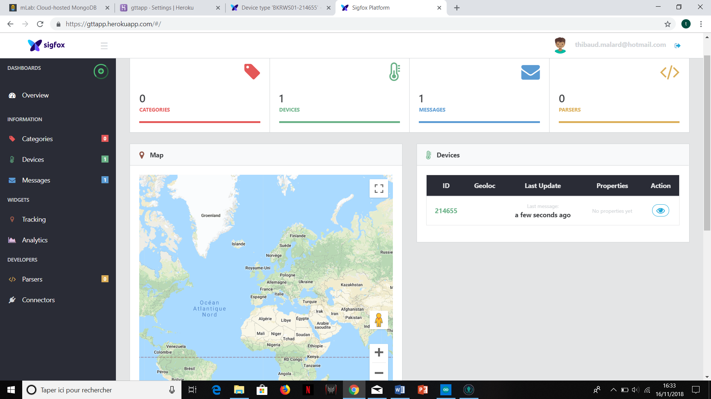

A screenshot of a computer screen


A screenshot of a computer


A screenshot of a computer


A screenshot of a computer


A screenshot of a computer screen


A screenshot of a computer

